1. Overview 2

2. E-R diagram 2

1.1. Employee 2

1.2. Holiday Calendar 3

1.3. Leave Category 3

1.4. Leave Type 3

1.5. Leave Configuration 4

1.6. Leave 4

3. Requirements 4

3.1. Point-and-click 4

3.1.1. Validation 4

3.1.2. Layout 5

3.1.3. Security 5

3.1.4. Automation 5

3.1.5. Analytic 6

3.2. Apex - Visualforce 6

# Overview

The leave management application called eLeaveForce. In this application, an employee can request a particular type of leave and his/her manager can approve the leave. We will maintain the leave types and leave categories as reference data (user defined data). A holiday calendar will be maintained for this leave management application.

# E-R diagram

There are six custom objects that are used to track the data of the leave management app. They are as follows:  
• Employee  
• Holiday Calendar  
• Leave (main leave object)  
• Leave Type  
• Leave Category  
• Leave Configuration

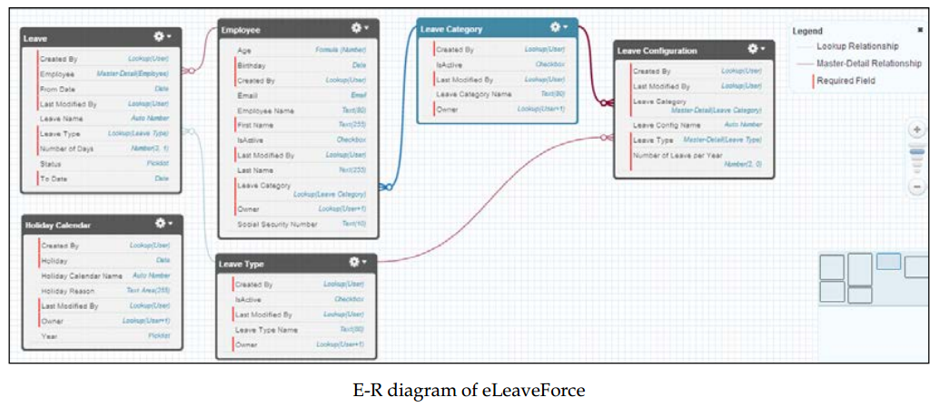

According to the requirement, these objects are connected with relationships as illustrated in the E-R diagram.

Use the following details of custom fields and particular data type to  
complete the data model of the leave management application:

1.1. Employee  
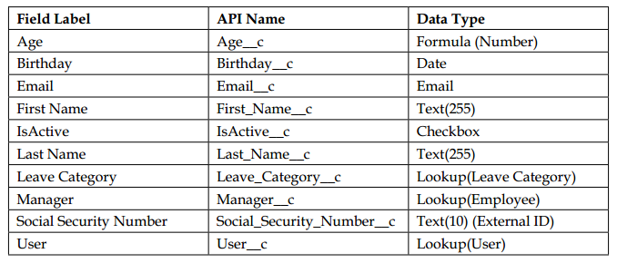

Name field of Employee records will be populated with the value of EMP-1, EMP-2,  
EMP-3, so on.

## **1.2. Holiday Calendar**

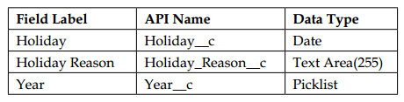

Year field will be from 2015 - 2020

## **1.3. Leave Category**

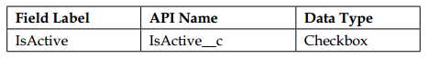

## **1.4. Leave Type**

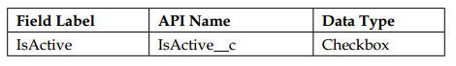

## **1.5. Leave Configuration**

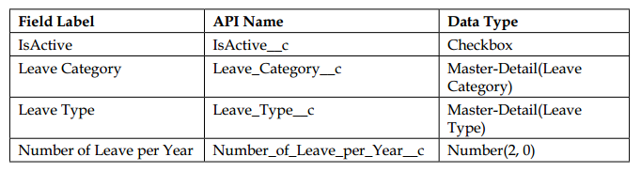

## **1.6. Leave**

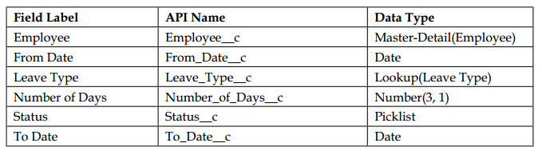

Status field included values: New, Approval Pending, Approved, Rejected, Delayed, Canceled

Leave Type field included values: Annual Leave, Casual Leave, Medical Leave, No Pay Leave, Deployment Leave, Maternity Leave, Special Leave

# Requirements

## **3.1. Point-and-click**

### 3.1.1. Validation

Age field of Employee object will be automatic calculated by formula: (today - birthday)/365

Validation Rule on Social Security Number field is not empty and format as 000-00-0000. The error message is “Invalid format”.

From Date field of Leave object must be from today. If not, error message (Invalid date) will be displayed.

### 3.1.2. Layout

Setup Search Layout and Tab View of Holiday Calendar object as below

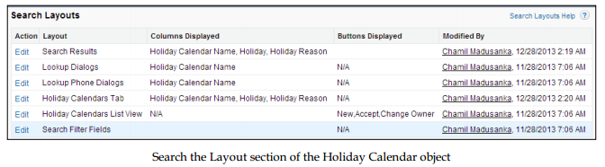

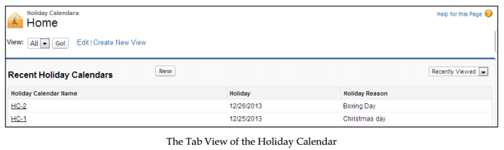

### 3.1.3. Security

Setup Employee tab just only display on eLeaveForce application.

In the leave management application, There are four types of users such as System admin, Employee, Manager, and Human Resources user (HR User). The HR user has complete access to the entire leave database, along with the customization of the applications. The employee can only apply for leave, view the leave history, and view the leave balance. The manager can only view and approve the particular leave records.

In our leave management application, there is sensitive information such as social security number and leave data. The social security number can only be seen by the employee to whom it belongs. The others cannot see that in the leave management application. The leave data of a particular employee can be accessed by that particular employee and the related manger; also, the employee can create the leave record and the manager can update the record.

### 3.1.4. Automation

Setup automating business process to cover below requirements:

* Create a task and assign to the particular manager, send an e-mail that notifies the particular manager when a leave request is made.
* If the manager doesn't respond to the leave request 10 days after the record created date, update the status field as **Delayed,** and automatically send an e-mail reminder to him/her.
* The employee wants to request a leave for a particular day or date range and requests it from the manager. After the manager has approved, the HR will approve the leave. The manager can approve or reject the approval request via e-mail by replying to the e-mail with approve, approved, yes, reject, rejected, or no on the first line of the e-mail body and adding comments in the second line.

### 3.1.5. Analytic

Create a report to retrieve the leave records of employees and is grouped by the **Leave Type** column

## **3.2. Apex - Visualforce**

Use Apex and Visualforce to do below requirements:

* User can apply and process a leave through an e-mail. Details are:

1. The subject of the incoming e-mail must contain the leave type (Annual  
Leave, Casual Leave, Medical Leave, and so on). For example, the subject  
must be in the following format:  
Annual Leave  
2. Sender's e-mail will match with that employee's record (to identify the  
person who has sent a request for the leave) and it will create a leave record  
for that employee.  
3. The e-mail body must contain two date values, which define the "from" date and "to" date. In this e-mail, there is not accept any attachments. After processing, a leave record will be created and then it will be sent for approval.

For example:

User create an email as below

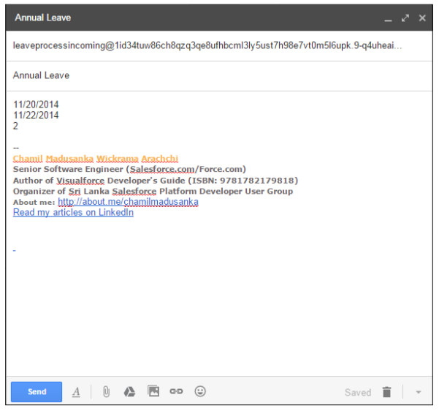

The e-mail will be received by the e-mail service, and then it will be processed through the Apex handler. On a successful read, a new leave record will be created and submitted for approval. The following screenshot illustrates the created record:

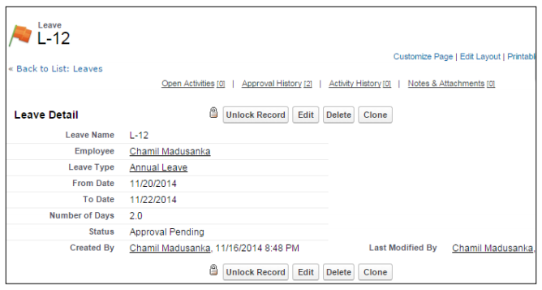

* User can apply and process a leave through SFDC’s layout as below:

When an employee applies for leave, a leave request record will be inserted to the Leave object. In the Leave object, there are two fields called From_Date__c and To_Date__c, which are used to capture the leave starting date and leave end date respectively. And we have the field called Number_of_Days__c to capture the number of leave days in between the leave starting date and end date. If any of the preceding validations fail, then all the operations will be stopped returning a suitable error message.

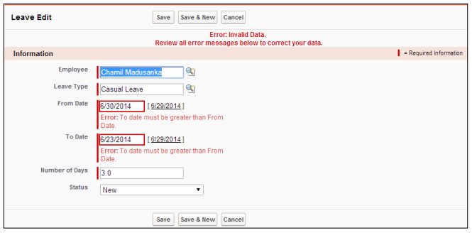

* User can use below layout to view his/her information

